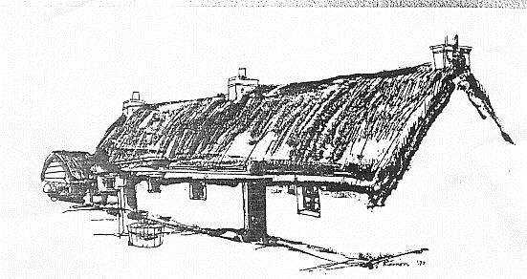
A Scottish Charitable Incorporated
Organisation No. SC002786

VOLUNTEER APPLICATION FORM

Thank you for your interest in volunteering with us! Please complete this form and return to the museum – you may continue on the reverse if there is not enough space.

Name

Address

Telephone: (Home) (Mobile)

Email:

Do you have any health issues, allergies or disabilities that we need to be aware of?

Yes No

If yes, please provide further details and indicate if any special arrangements or awareness is needed:

Please provide details of an emergency contact:

Name:

Telephone number:
We have a variety of opportunities available. Please let us know what types of volunteering you are interested in:

Front of House Collections Events

Research Maintenance/Cleaning

Please tell us about any relevant skills you have (for example, IT, photography)

Relevant hobbies and interests

Days and times available to volunteer:

 | Mon | Tues | Wed | Thurs | Fri | Sat | Sun
a.m. |  |  |  |  |  |  | Closed
p.m. |  |  |  |  |  |  | Closed

Please use this space if you need to give more details on your availability, e.g. available every second week, changing work rota etc:

Please say briefly why you are interested in volunteering at Glencoe Folk Museum

What do you hope to get out of volunteering? (e.g. develop new skills, meet like-minded people…)

Where did you hear about this volunteering opportunity?

At the museum/event Current volunteer Online/Social Media

Other (please give details)

Certain volunteering roles, involving contact with children, young people and vulnerable adults will require declaration of unspent convictions and for a disclosure to be obtained. This will only be sought with your consent at the appropriate stage for successful applicants.

A previous conviction does not necessarily mean you will be unable to volunteer with us.

Signed Date

Please return this form to: Curator, Glencoe Folk Museum, Main Street, Glencoe, PH49 4HS or Email: curator@glencoemuseum.com

